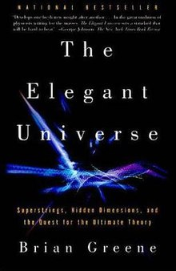

Buku The Elegant Universe: Superstrings, Hidden Dimensions, and the Quest for the Ultimate Theory karya Brian Greene

Brian Greene, one of the world's leading string theorists, peels away layers of mystery to reveal a universe that consists of eleven dimensions, where the fabric of space tears and repairs itself, and all matter?from the smallest quarks to the most gargantuan supernovas?is generated by the vibrations of microscopically tiny loops of energy. The Elegant Universe makes some of the most sophisticated concepts ever contemplated accessible and thoroughly entertaining, bringing us closer than ever to understanding how the universe works.

Hanya untuk percobaan upload di Ebookhub